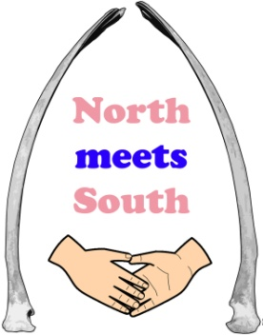
Invitation to Tender
Children and Young People
April 2016

North Meets South Big Local

Organisation: The London Community Foundation, on behalf of the North Meets South Big Local Partnership, for Marks Gate & Chadwell Heath
Services required: Research, consultation and strategy development - Analysis of provision for, and the potential engagement of, children and young people in the Big Local area of Marks Gate & Chadwell Heath, Dagenham

- Background and overview
Big Local is a long term innovative programme that aims to achieve lasting change in 150 areas in England. It provides a mixture of funding, finance and support. Each Big Local area is receiving at least £1m Lottery funding over at least the next 10 years, which residents themselves will be in charge of spending on ways to improve their community. It seeks to enable people who live in the areas to build on local talents and aspirations so they can identify and act on their own needs to make their areas even better places to live, both now and years to come. Each area will also be given support, training, and networking opportunities to help them develop their plans and empower them to find solutions that work for their communities.
Local communities drive Big Local in their area. The programme supports, challenges, trains and encourages people to develop and drive Big Local in their area. Big Local supports communities to identify issues and plan and develop solutions. This provides a sustainable approach to long-term issues and ultimately creates even better places to live.
The Big Local Programme aims to:
- Enable communities to better identify local needs and take action in response to these needs;
- Increase the skills and confidence of local people so that they can continue to respond to, and identify, needs in the future;
- Enable the local community to make a difference in the areas of need it prioritises;
- Foster a feeling that local residents have, through their hard work, made their local areas better places to live.
North Meets South Big Local includes Marks Gate and parts of Chadwell Heath, located within the London borough of Barking and Dagenham.

A Partnership of local people has been formed to guide the overall direction of Big Local in the area, and they are called North Meets South. Support for children and young people is one of the priority areas the Partnership have identified in 2016.

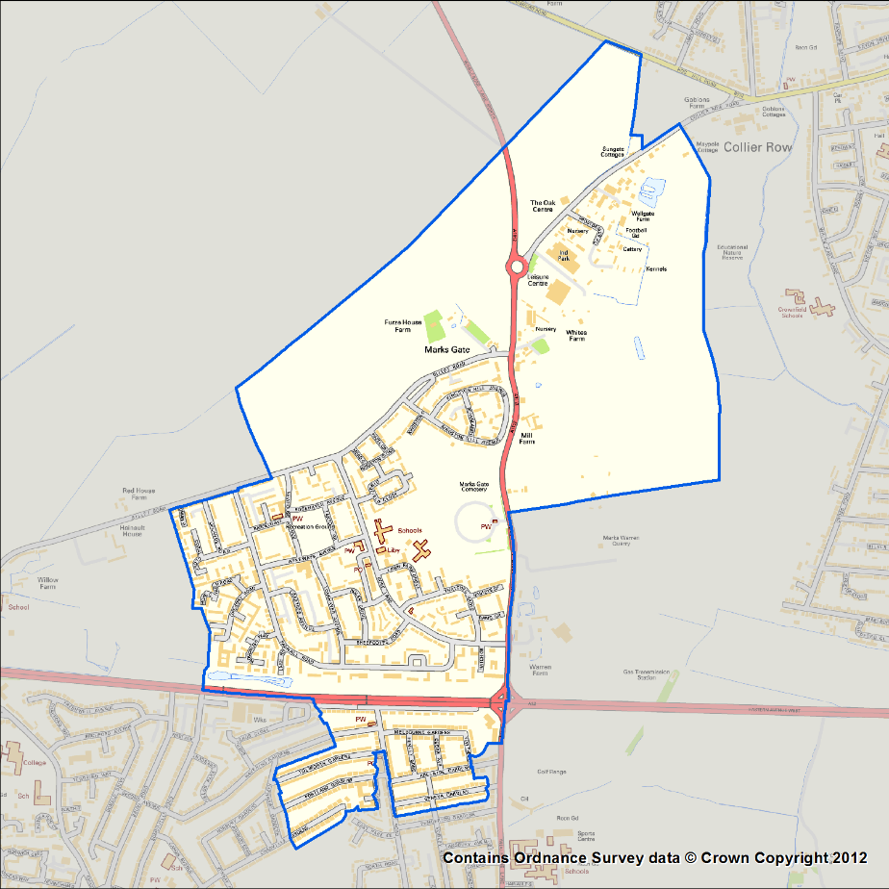
Map of the Big Local area, incorporating Marks Gate & part of Chadwell Heath.

- Purpose of the tender
North Meets South Big Local requires a consulting partner to work with the Partnership and local community to develop a strategy for the priority area: children and young people. Through previous engagement with families and young people in the area, feedback has highlighted:
- A lack of affordable activities and provision for children, particularly during the school holiday period, and the need for a menu of provision;
- A lack of awareness of services available locally for young people (including personal development, support and leisure opportunities) causing barriers to participation.
The Partnership now wish to commission more detailed consultation and research in the area, mapping existing provision, identifying gaps in provision, and consulting with children, young people and families on the type of provision they would like to see in the area – with a view to developing a two year strategy and action plan for the Partnership to implement.

Specifically, the organisation or consultant will be tasked with the following:
- Mapping existing services and activities available for young people and children within the North Meets South Big Local Area;
- Engaging with children (defined as 12 years and younger), young people (defined as between 12 and 19 years old) and service providers, in roughly equal numbers, to establish:
  - which of the available services or activities are utilised and which are not
  - what are the barriers to existing provision (if any)
  - how to ensure people can find out about activities available to them;
- Identifying gaps in or limitations to existing provision;
- Engaging with children, young people and families to establish what type of activities/services for children and young people they would like to see provided in the North Meets South Big Local Area, forming a recommended menu of activities;
- Developing a two year strategic plan for the Partnership covering the findings from the above areas and making recommendations on key opportunities, actions and priority areas for implementation;
- Reporting to the Partnership on the findings of this research in writing and in person.

- Outcomes
Anticipated outcomes from this piece of work include the following:
- Increased opportunities for children and young people in the North Meets South area;
- Increased awareness of local provision/activities for children and young people (and their families);
- Increased aspirations, attainment levels and achievement of children and young people;
- Increased engagement of children and young people in the area, in both engaging in shaping the environment in which they live and in accessing existing and new provision;
- Stronger relationships between young people, the wider community and local service providers.

It is anticipated additional and more specific outcomes will be identified by children, young people, families and services providers during this piece of work, and that these will be identified in consultant’s proposed strategy.

- Reporting
Day-to-day reporting will be to the Partnership’s Locally Trusted Organisation (LTO), The London Community Foundation.
Ultimate oversight will be from the North Meets South Big Local Partnership, and you will be asked to attend a minimum of 2 Partnership meetings to discuss your findings and make recommendations.
You will be required to present a written interim update on findings at a mid-way point, and a final written report.

- Applications:
We welcome applications from organisations and individual consultants – we will also consider partnership applications drawing on people’s expertise in different areas, although we would ask for no more than two organisations/individual consultants to work in partnership and would need one main point of contact for this piece of work.
To apply please send a covering letter of no more than three sides, outlining your experience, suggested methodology, timescales and budget, alongside a CV including two referees.

The closing date for applications is: Wednesday 11th May 2016
Please send your application to: Matthew Harriott at The London Community Foundation: matthew.harriott@londoncf.org.uk.
If you have any queries about the tender, please call Matthew Harriott at The London Community Foundation on 020 7582 5117.

The London Community Foundation
Unit 7 Piano House, 9 Brighton Terrace, London SW9 8DJ
www.londoncf.org.uk info@londoncf.org.uk
Tel: 020 7582 5117
Registered Charity No 1091263 and company limited by guarantee no. 4383269
