Dragons Den – Grants Scheme

North Meets South Big Local are pleased to announce the return of Dragons Den.This scheme exists to encourage residents to explore new life skills and for partner organizations to create opportunities within our catchment area. The aim is to offer grants to activities which support the key areas of focus in our partnership plan for 2021/22 (see our website for more information). These are:
- Physical improvement of public facilities/community assets within the NMS catchment area
- Social activities for residents of every age group
- Positive attitudes and opportunities to foster a “can-do” mentality within the area by encouraging residents to take responsibility for change within the area

Application process
- Application and supporting documents sent to NMS worker within the deadline: 6th September 2021
- Steering group conducts due diligence via a 3rd party organization
- Steering group short-lists application prioritising the immediate needs of the area/their partnership vision
- Dragons Den Community voting event October 2021
- Grants will be offered to applicants with the most votes via BACC as per grants conditions, projects start November 2021. Applicants must provide evidence of the following before grants are awarded:
  - Public liability insurance
  - DBS certificates of facilitators
  - Annual accounts
  - Name, address and contact details of management committee
  - Governing document
  - Safeguarding policy if applicable (children and/or vulnerable adults)
  - Bank statement as the funding is designed to enable small and new locally based groups to deliver activities
  - An invoice with a breakdown of expenses
  - Risks assessments
If applicants do not have the relevant documentation and policies in place, they can link with a nurture organisation to whom we can pay the funding on their behalf. However, the nurture organisation will need to provide all the documentation listed above. We can clearly detail this information in the Fund Guidelines and relay information to interested organisations. Our payment process is relatively quick with two payment runs a week, so provided the correct documentation is provided there will not be any delays.

Application Guidelines
Grant applications will be open at 9am on the 1^{st of} July 2021. Grants are available to individuals and organisations for projects that will primarily and directly benefit residents of the North Meets South area (see the map below).

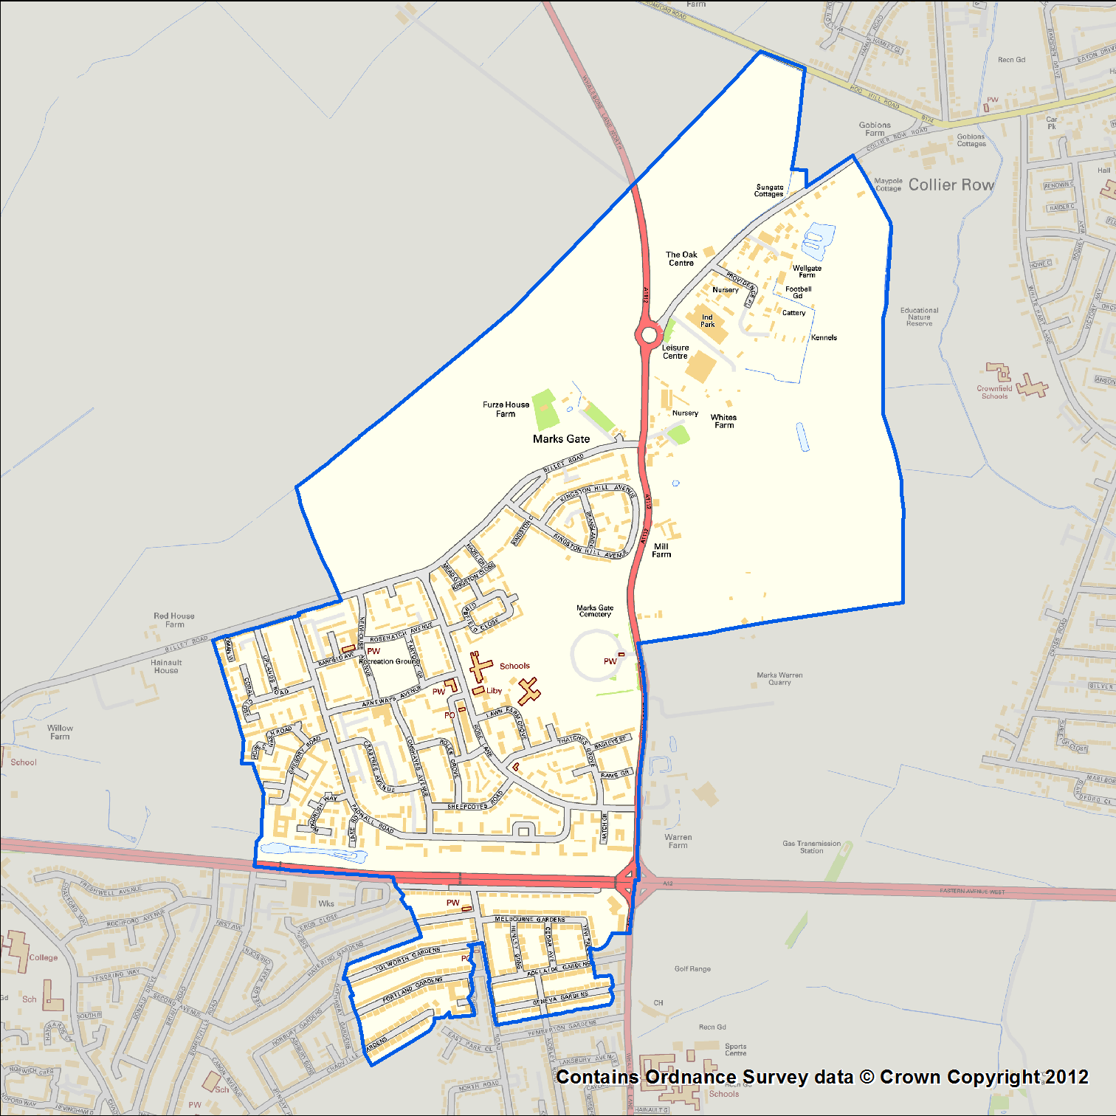

All applications must be received by 5pm on Monday 6th September 2021.

If you need help understanding these grant guidelines or the application form, please contact Catherine at North Meets South Big Local on 074 3598 1947 or nmsworker17@gmail.com.

Project themes
Your Dragon’s Den project must address at least one of these core themes for the North Meets South area:
□Physical Improvement
□Social Activities & Cohesion
□Positive attitudes & opportunities
See below some ideas of the type of activities we might fund:
Homework club Youth engagement activities
IT & social media skills Social Enterprise ventures
Exercise classes ESOL Classes
Befriending schemes Mentoring schemes for youth/young adults
Dance & Music skills training programmes Apprentices & Training programmes
Social inclusion activities for lone parents
Child minding opportunities for low-income parents
Indoor/ outdoor sports for adults and young people
Community Events (trips/fun-days/ street parties/sightseeing/theatres/outdoor cinemas)
Arts & crafts for young adults and children (including knitting, jewellery & costume making)

SOME HEADLINE STATISTICS ABOUT THE NORTH MEETS AREA
Families | 42% of North Meets South families with dependent children are Lone Parent families, compared with 35% across Barking & Dagenham | Education | In the North Meets South area, pupil attainment based on GCSEs at Key Stage 4 is 321 points on average compared with 348 points across Barking & Dagenham
Vulnerable groups | 27% of children are living in poverty in the North Meets South area compared with 23% across Barking & Dagenham | Economy | 32% of people have no qualifications in the North Meets South area compared with 28% across Barking & Dagenham
Communities & environment | 7,735 people live in the North Meets South area. 57% are 'satisfied with their 'neighbourhood', the same as the average across Barking & Dagenham | Health & wellbeing | 20% of people have a limiting long-term illness in the North Meets South area compared with 16% across Barking & Dagenham

How much can you apply for?
- Individuals: up to £500
- Established Organisations
- Small Grants for up to £3000
- Large Grants: we are open to receive these proposals for activities where there is an exceptional priority match with our current local plan and vision for Marks Gate & North Chadwell Heath
What can we fund?
- Costs of delivering an activity including room hire, staff costs and volunteer expenses
- Event costs (including event registration fees e.g., Temporary Event Notice costs)
- Equipment costs, where there is a clear plan for ongoing community benefit
- Insurance costs and DBS checks where needed
- Capacity building training for residents of North meets South catchment area
- We can fund running costs for existing or new projects
What we cannot funded
- Activities which the Local Authority has a legal duty to provide
- Purely for-profit commercial ventures
- Proposals which are not feasible or do not offer value for money
- Local statutory services e.g., schools, hospitals, etc. (‘Friends of’ groups and PTAs are welcome to apply)
- Party political, religious or sponsorship activities
- Spending that has already taken place
- Discriminatory activities
Who can apply for a grant?
Funding can be awarded directly to a constituted, not for profit organisations of any kind (e.g. registered charities, tenants and residents associations, other constituted community groups and CIC’s).
We are also able to award funding to individuals for their project, however this cannot be paid directly into an individual’s bank account. The funding will need to be received by a constituted, not for profit organisation with their own bank account, and managed on the individual’s behalf. Any consents needed (e.g., for an organisation to receive funds on your behalf) will also need to have been confirmed before a grant released.
Dragon’s Den applicants must have appropriate safeguarding, health & safety, equal opportunities, and insurance policies in place. Priority will be given to organisations and individuals based/already working within the North Meets South area.

Grant process timeline
- Application open 1st July: deadline for receiving completed Dragon’s Den grant applications is 5pm on Monday 6th September
- Dragon’s Den community voting event October 2021 (dates tbc). You will need to set up a display about your project for the community voting event
- Dragon’s Den projects will run from November 2021 and will need to include an activity during half term and school holidays. All projects must be completed within 12 months of the grant being awarded
- You will need to hold some activity (e.g. taster sessions) on both sides of the A12 within the North Meets South area
- You will need to return a completed monitoring/Impact report to the partnership by the date given to you in your offer letter

Shortlisting & Community Voting Event
All applications will be reviewed by the North Meets South Steering Group and The Big Local Trust Rep.
If your application is shortlisted you will be invited to attend the Dragon’s Den community voting event in October, where you will host a display table at Marks Gate Community Centre to allow residents to view information about your idea, in order to make a vote. This might include photographs, copies of your application form, props or other information.
During the voting event all applicants will also be invited to deliver a 90 second ‘pitch’ to present the idea to the community. If you do not want to make a pitch you can submit a presentation for a member of the North Meets South team to read out on your behalf.
Throughout the day, members of the public will be present and will vote for the projects they would like to see funded. Please encourage your friends and family to come along and support your application, if you are shortlisted.
Grant agreement
- Any funding determined by the community vote is a verbal, non-binding agreement and all applications will need to satisfy due diligence and eligibility checks
- Terms & Conditions will be sent out to all successful applicants which must be agreed and signed prior to any payments being made
- Grants will be paid to the applicant or their nominated organisation’s bank account, following successful checks
- Grant recipients must be fully committed to completing their project as described in the application form and as presented at the community voting event
- All grant recipients will be expected to report back on how the money was spent, what activities took place and the benefit to participants, by the date given in their offer letter

Publicity
- Successful grant applicants will be included in North Meets South publicity; this may include photographs to use in print and on our website
- Successful Dragon’s Den projects will also need to provide consented digital photographs of participants and the project in progress, for North Meets South to use in print and on our website
- Dragon’s Den projects will need to actively publicise activities on both sides of the A12 to reach people across the North Meets South area
- All Dragon’s Den project publicity must include the North Meets South logo
- Successful grant applicants will need to keep North Meets South updated on where and when their Dragon’s Den projects will be taking place, throughout the grant year
How to apply for a Dragon’s Den grant
You can download an application form on the North meets South Website: www.nmsbl.org.uk. You can also request an electronic/hard copy by contacting Catherine on 07419 285 839 or nmsworker17@gmail.com OR pick-up a copy from any of these locations:
- St Mark’s Church
- Eastern Road Baptist Church
- Marks Gate Community Centre
All applications must be received by 5pm on Friday 6th September 2021. Please return your completed application form by email with Dragon’s Den Application in the subject line to: nmsworker17@gmail.com.
If you are unable to submit your application by email, please contact Catherine on 07419 285 839 or nmsworker17@gmail.com to arrange a physical submission date at Mark’s Gate Community Centre.
For more information about North Meets South Big Local Partnership and the needs of our catchment area, ask for our latest newsletter and visit our website at www.nmsbl.org.uk, we look forward to receiving your application

