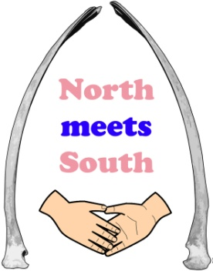
Invitation to Tender
Open Spaces
April 2016

North Meets South Big Local

Organisation: The London Community Foundation, on behalf of the North Meets South Big Local Partnership, for Marks Gate & Chadwell Heath
Services required: Research, consultation and strategy development – Audit and analysis of potential to develop and improve usage of open spaces in the Big Local area of Marks Gate & Chadwell Heath, Dagenham

- Background and overview
Big Local is a long term innovative programme that aims to achieve lasting change in 150 areas in England. It provides a mixture of funding, finance and support. Each Big Local area is receiving at least £1m Lottery funding over at least the next 10 years, which residents themselves will be in charge of spending on ways to improve their community. It seeks to enable people who live in the areas to build on local talents and aspirations so they can identify and act on their own needs to make their areas even better places to live, both now and years to come. Each area will also be given support, training, and networking opportunities to help them develop their plans and empower them to find solutions that work for their communities.
Local communities drive Big Local in their area. The programme supports, challenges, trains and encourages people to develop and drive Big Local in their area. Big Local supports communities to identify issues, and plan and develop solutions. This provides a sustainable approach to long-term issues and ultimately creates even better places to live.
The Big Local Programme aims to:
- Enable communities to better identify local needs and take action in response to these needs;
- Increase the skills and confidence of local people so that they can continue to respond to, and identify, needs in the future;
- Enable the local community to make a difference in the areas of need it prioritises;
- Foster a feeling that local residents have, through their hard work, made their local areas better places to live.
North Meets South Big Local includes Marks Gate and parts of Chadwell Heath, located within the London borough of Barking and Dagenham.

A Partnership of local people has been formed to guide the overall direction of Big Local in the area, and they are called North Meets South. Access to and use of Green and Open spaces is one of the priority areas the Partnership have identified in 2016.
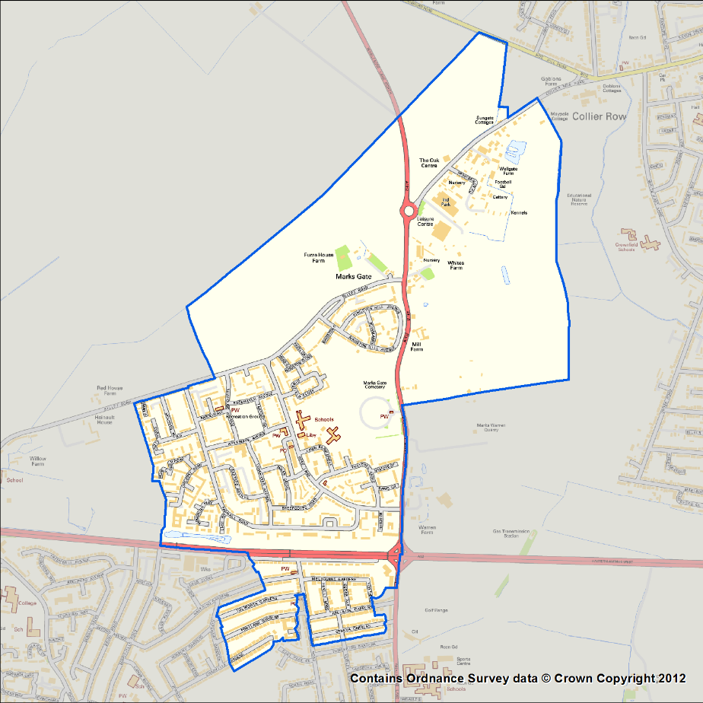

Map of the Big Local area, incorporating Marks Gate & part of Chadwell Heath.

- Purpose of the tender
North Meets South Big Local requires a consulting partner to work with the Partnership and local community to develop a strategy for the priority area: Green and Open Spaces. Previous community engagement highlighted the need for improvements to the local environment, and in particular local open and green spaces. The area benefits from a number of open spaces including two parks, Tantony Green in Marks Gate, and St Chad’s Park on the boundary of the Big Local area.
Consultation previously highlighted the need for:
- Improved access to and use of open and green spaces in the area for people of all ages, including older residents;
- More places for children to play which are safe and will not cause disruption to other residents;
- A greater range of age-specific open spaces (including play areas for children and young people);
- Improvement and regeneration of existing open and green spaces.
In light of these initial findings, the Partnership would like to commission more in-depth research in the area that; audits and maps existing green or open spaces, identifies needs for investment or improvement and consults with local people over what changes they would like to see – with a view to developing a two year strategy and action plan for the Partnership to implement.

Specifically, the organisation or consultant will be tasked with the following:
- Auditing all of the green and open spaces (including parks) in the Big Local Area, including:
- mapping existing spaces
- identifying ownership, maintenance & development responsibility
- identifying any current plans for improvements or development of existing spaces
- identifying the potential for Big Local to be involved in improving, developing, or increase the use of existing spaces by local residents;
- Assessing the quality of each open space in the Big Local area;
- Engaging with stakeholders and residents of the North Meets South Big Local Area to establish:
  - Current usage patterns of green and open spaces
  - What residents would like to see provided in the Big Local area
  - Appetite for projects and activities that could be run in open spaces in the Big Local area;
- Developing a strategic, two year plan for the Partnership to improve local residents’ access to and use of using open spaces, including recommendations for areas of opportunity, potential actions and priority areas for the Partnership;
- Reporting on these findings in writing and in person.

- Outcomes
Anticipated outcomes from this piece of work include:
- Increased access to green and open spaces for all residents in the North Meets South Big Local Area, through both greater awareness of available spaces, improved environment and provision;
- Improved local environment for local residents;
- Improved outdoor activities in the local area, accessible to local residents;
- Greater number of community led activities and projects in local open spaces.

- Reporting

Day-to-day reporting will be to the Partnership’s Locally Trusted Organisation (LTO), The London Community Foundation.
Ultimate oversight will be from the North Meets South Big Local Partnership, and you will be asked to attend a minimum of two Partnership meetings to discuss your findings and make recommendations.
You will be required to present a written interim update on findings at a mid-way point, and a final written report.

- Applications
We welcome applications from organisations and individual consultants – we will also consider partnership applications drawing on people’s expertise in different areas, although we would ask for no more than two organisations/individual consultants to work in partnership and would need one main point of contact for this piece of work.
To apply please send a covering letter of no more than 3 sides, outlining your experience, suggested methodology, timescales and budget, alongside a CV including two referees.

The closing date for applications is: Wednesday 11th May 2016
Please send your application to: Matthew Harriott at The London Community Foundation - matthew.harriott@londoncf.org.uk.
If you have any queries about the tender, please call Matthew Harriott at The London Community Foundation on 020 7582 5117.

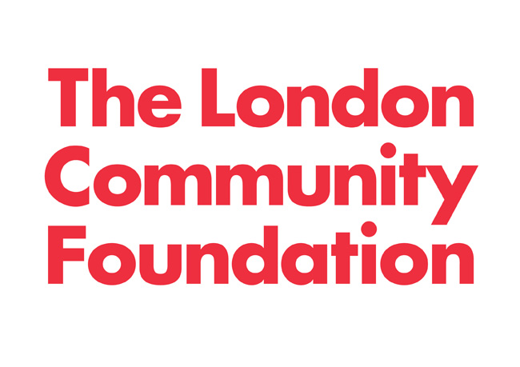
The London Community Foundation
Unit 7 Piano House, 9 Brighton Terrace, London SW9 8DJ
www.londoncf.org.uk info@londoncf.org.uk
Tel: 020 7582 5117
Registered Charity No 1091263 and company limited by guarantee no. 4383269

