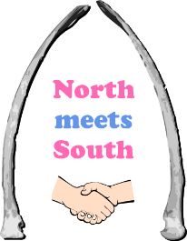
North Meets South Big Local
Dragons’ Den Small Grants 2019/20

Application Form

Type of applicant: Association Charity CIC Individual 18+ Other, please state:

Please tick to confirm that you have read and will abide by the grant guidelines, including the publicity and monitoring requirements.

Your name:

Your email: Your phone:

Your address (including post code):

Organisation name (if applying as a group):
- What is the name of your Dragon’s Den project?

- Please describe your project, saying:

- What your project will do
- Why your project is needed
- Who will take part and benefit
- Number of participants
- How long your project will run
- Where and when it will run
- How and where you will advertise your project

- Which of the North Meets South core themes does your project come under?  Your project must address at least one | Green & open spaces  (e.g. gardening, park events)  Strengthening Communities  (e.g. children, families, young people, older people)  Community economic development  (e.g. homework, mentoring, employability, enterprise)
- How much funding are you applying for?

- Please provide a breakdown of your budget here, setting out what you need to pay for.
If the total cost is more than the grant you are applying for please say where the other funding comes from e.g. will you be charging project participants?

Please note: Any participant charges must be for project delivery costs not covered by the Dragon’s Den grant
- Who will be responsible for making your project happen and what experience do they have?

Please tick to confirm that you have appropriate insurance, safeguarding, health & safety, and equal opportunities policies in place. If you are an individual, please tick to confirm that you will follow North Meets South’s policies and procedures.

I confirm that the information on this form is true and correct. I am authorised to make this application. I will comply with the grant guidelines and provide all requested documents.

Signature: Date:

